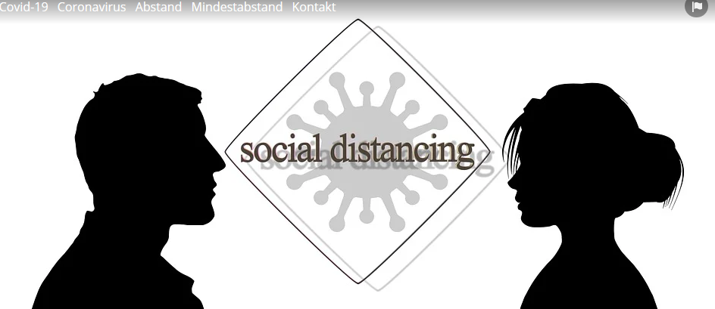
https://pixabay.com/de/illustrations/covid-19-coronavirus-abstand-4940638/
__________________________________________________________________________________
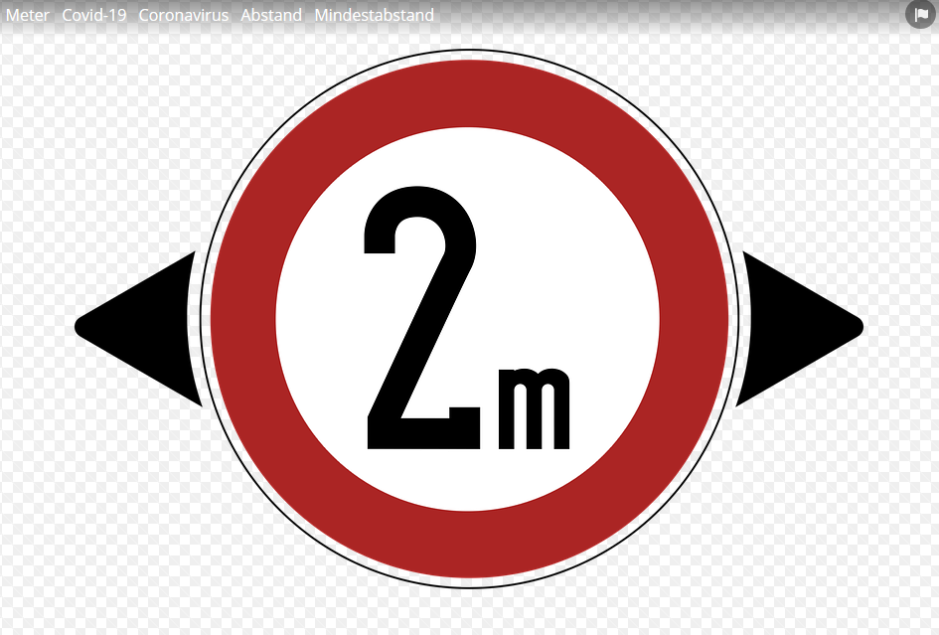
https://pixabay.com/de/illustrations/meter-covid-19-coronavirus-abstand-4962678/
__________________________________________________________________________________
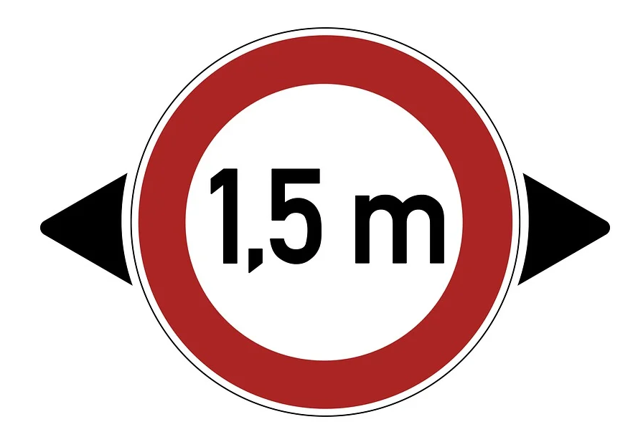
https://pixabay.com/de/illustrations/meter-covid-19-coronavirus-abstand-4969147/
__________________________________________________________________________________
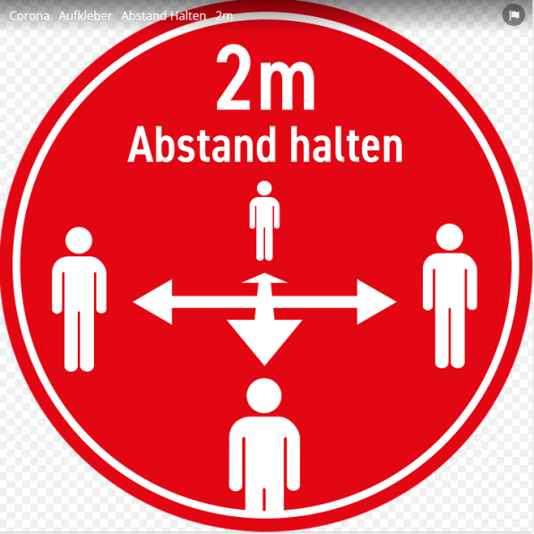
https://pixabay.com/de/vectors/corona-aufkleber-abstand-halten-2m-5016829/
__________________________________________________________________________________
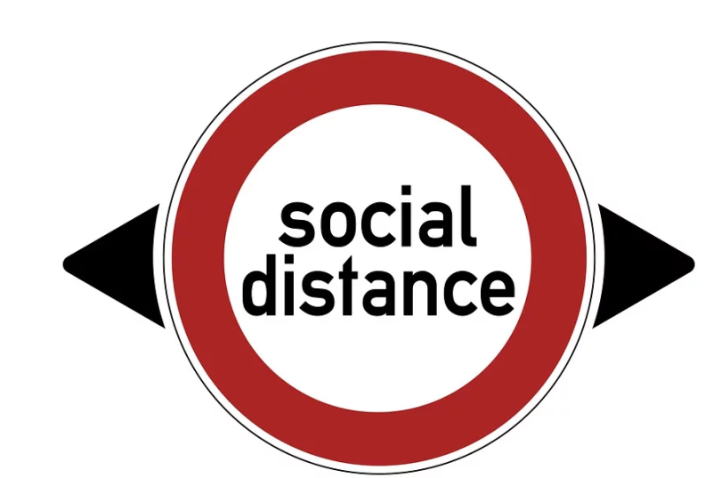
https://pixabay.com/de/illustrations/covid-19-coronavirus-soziale-distanz-4962685/
__________________________________________________________________________________
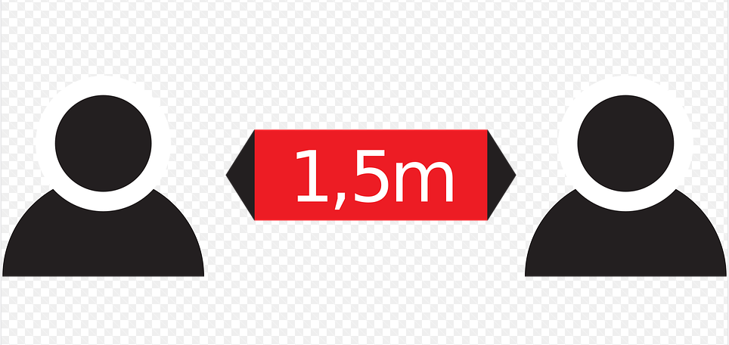
https://pixabay.com/de/illustrations/abstand-abstand-halten-corona-5003595/
__________________________________________________________________________________
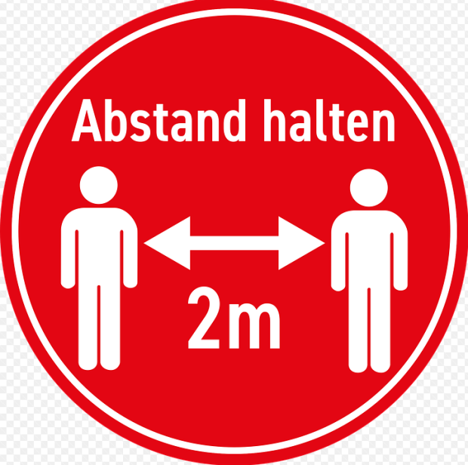
https://pixabay.com/de/vectors/corona-aufkleber-abstand-halten-2m-5016826/
__________________________________________________________________________________

